Commercial TnH+IAQ Sensor with Modbus RTU/WIFI-MQTT Communication – Datasheet
1. Product Overview
WIN-SN-TnH-IAQ is a versatile data acquisition device designed for real-time monitoring in industrial applications. Providing flexibility for various measurements. The device integrates seamlessly with Modbus RTU, offering reliable communication and long-range data transfer over several meters, making it ideal for large-scale installations.
Its robust design makes it suitable for installations in HVAC systems, environmental monitoring, and process control. With configurable data sampling rates, multi-sensor compatibility, and easy configuration, WIN-SN-TnH-IAQ ensures accurate Air-quality, Temperature and Humidity data acquisition and reliable performance in demanding industrial environments, making it an excellent choice for industrial and IoT applications. Additionally, it features a 4-digit 7-segment display that provides real-time measurement data, allowing users to monitor sensor readings directly without requiring an external interface.
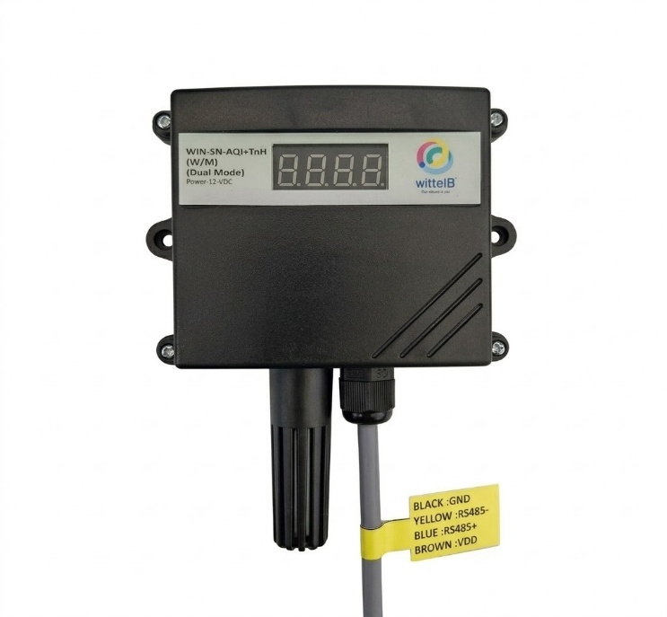
Ex: - Product Image
2. Technical Parameters
- Measuring Parameters of Air Quality, Temperature, and Humidity.
- Response Time: Less than 2 seconds
- Modbus RTU communication

 | Sensor Name | Temperature Measuring Range | Humidity Measuring range | AQI/ GAS/  Pressure | Measuring  Accuracy
☐ | BME280 | -40 ~ 85°C | 0~100% RH. | 300 - 1100 hPa | 1.0°C, 3.0 %RH,  1.0 %hPa
☐ | BME680 | -40 ~ 85°C | 0~100% RH. | 300 - 1100 hPa  & 0 – 500 IAQ | 1.0°C, 3.0 %RH,  0.6 %hPa, 15 %IAQ
☐ | BME688 | -40 ~ 85°C | 0~100% RH. | 300 - 1100 hPa  & 0 – 500 IAQ | 0.5°C, 3.0 %RH,  0.6 %hPa, 15 %IAQ
☐ | BME690 | -40 ~ 85°C | 0~100% RH. | 300 - 1100 hPa  & 0 – 500 IAQ | 0.5°C, 3.0 %RH,  0.5 %hPa., 15 %IAQ

 | Product Configuration
☐ | TnH+IAQ+M
☐ | TnH+IAQ+M+D
☐ | TnH+IAQ+W
☐ | TnH+IAQ+W+D
☐ | TnH+IAQ+MRTU+WIFI
☐ | TnH+IAQ+MRTU+WIFI+D

3. Sensor Specifications
- Wide temperature range: −40 °C to +125 °C
- Full humidity range: 0 % to 100 % RH
- Power supply DC: 12-24V@1A.
- Product dimension: 85*85*36 mm.

- Certifications:

4. Power Supply Connection
DC Connection
- Use 12-24V@ 1A, Power supply.
- Don’t make loose connection.
Recommended Cable Electrical Characteristics
22 AWG Cable Shielded and twisted pair should be used.
Tinned Copper Recommended
Nominal Conductor DCR 14.7 ohm / 1000 ft
Nominal Capacitance 11 pf / feet (conductor to conductor)
High Frequency Non-Insertion Loss 0.5db / 100ft

5. Step-by-Step Configuration
- Connect the Device
  - Connect 12v-1A DC adaptor to power the board
  - Connect the Wi-Fi:- WittelB-SN-ATH, Password:- 123456789
  - Search browser enter default IP : 192.168.4.1
  - The device starts communication using default settings if not previously modified.
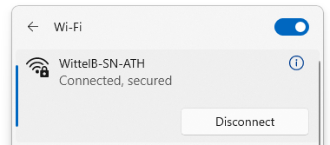

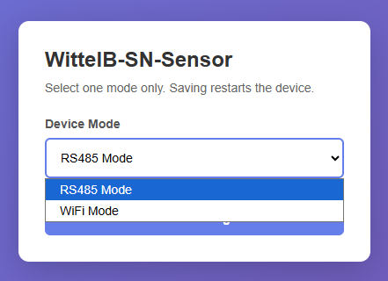
- Mode selection

  - Enter 192.168.4.1 in the browser search bar and select the Device Mode.
  - Select the device mode as RS485 Mode to get the sensor data via Modbus RTU, or select Wi-Fi Mode to get the sensor data in the MQTT cloud through the local Wi-Fi network.
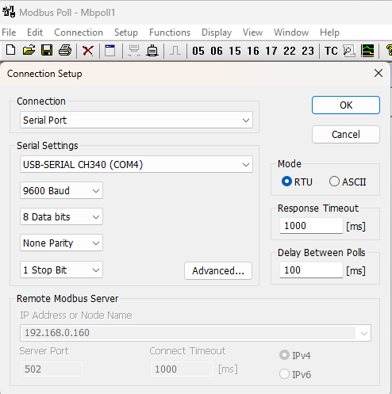
  - RS485-Mode

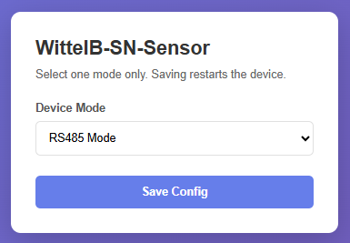

Image: 1 Image: 2

  - As shown in image 1 click Save Config and restart the device.
  - Refer to Image 2. Open MB Poll/Modbus Scanner and connect the device using default address.
RS485-Configuration:
- Communication Speed 9600 – 115200 Kbps (SW Selectable)
- Data Bits 8
- Parity None
- CRC Yes
- Slave ID 1, DIP (SW Selectable)
- Function Code 0X03 (Read Holding Register)

- Here is an example of receiving data on Mb poll software.
- Open Mb-poll software connect using configuration setting (Default baud rate is 9600 and slave id is 1).
- After connecting you will get data as shown below.
Important Note
- If you want to enter the baud rate 9600/19200/38400/57600/115200etc, enter it like this 960/1920/3840/5760/11520etc.
- After that press the reset button or reboot the system.
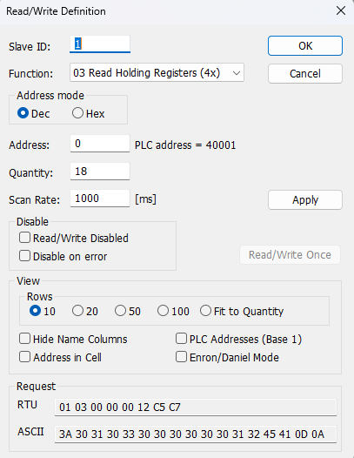
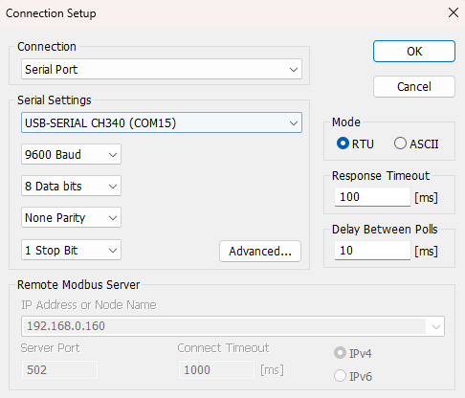
- Then you will get the present value of 11520 at 40011 baud rate (115200) and 2 at 40013 slave id.
- Above image Shows sensor data over Modbus with default Modbus settings
- Register 40001 Shows the Temperature, Register 40002 Shows the Humidity, Register 40003 Shows the IAQ
- Temperature 326 indicates 32.6, Humidity 458 indicates 45.8
- As you can see in the image above, the resistor 40011 – 960 represents the present baud rate (9600) of the board and 40013 – 1 represents the present slave id of the board.
- To change the baud rate and slave id Jumper should be in single/removed then, you must enter a value on the 40012 resistors for the baud rate and 40014 for the slave id as shown in the image below and restart the board.
- Now you can see data below image set 115200 baud rate and slave ID 10.
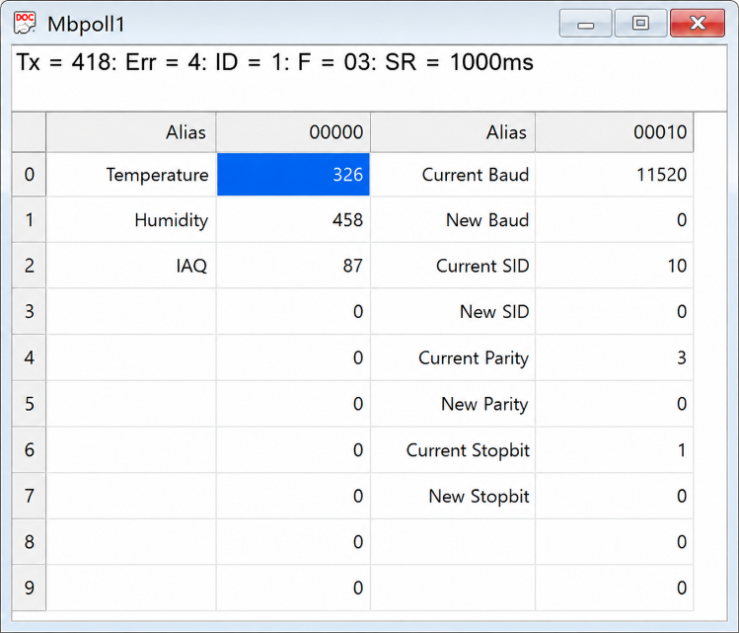
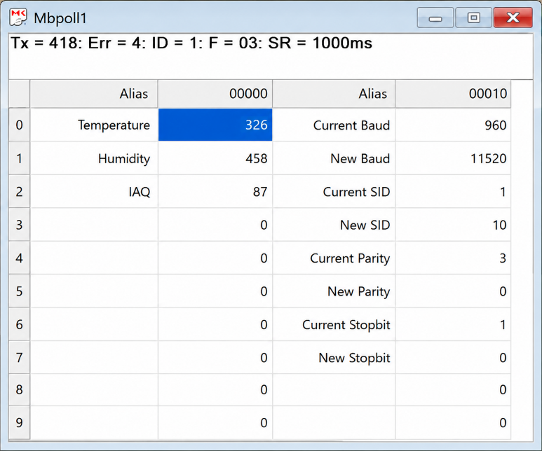

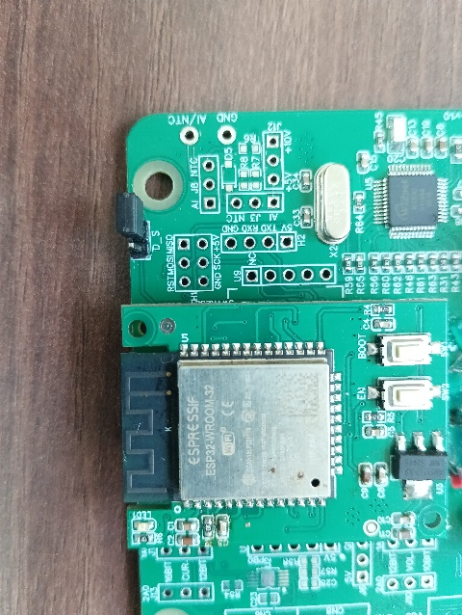
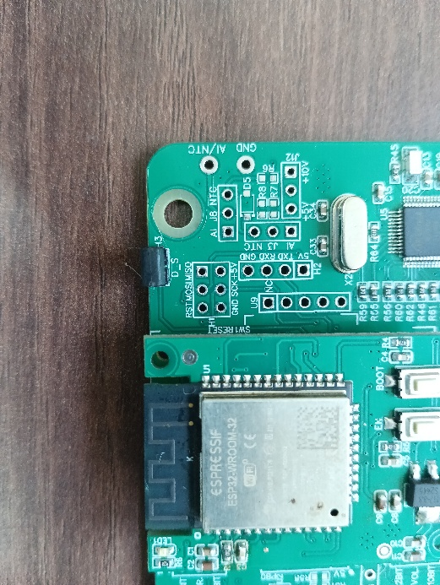

Config JUMPER
RESET JUMPER

Hard reset Setting
- Somehow you forgot the baud rate or slave id of the board then Place the jumper (as shown in the above image 1.1) from the board reboot the system or press the reset button (given on the board). Then you will get the default baud rate of 9600 and slave id 1.

ID | Function  Description | Register  Description | Modbus Function Code | Protocol | Data Type
1 | Temperature | 40001 | 0x03 | RS485 | 16-bit int
2 | Humidity | 40002 | 0x03 | RS485 | 16-bit int
3 | IAQ | 40003 | 0x03 | RS485 | 16-bit int
1 | Display Baud Rate (Default: 960) | 40011 | 0x03 | RS485 | 16-bit int
2 | Enter New Baud Rate | 40012 | 0x03 | RS485 | 16-bit int
3 | Display Slave ID (Default: 1) | 40013 | 0x03 | RS485 | 16-bit int
4 | Enter New Slave ID | 40014 | 0x03 | RS485 | 16-bit int
5 | Display Parity (Default: None-3 And for Odd-1, Even-2) | 40015 | 0x03 | RS485 | 16-bit int
6 | Enter New Parity | 40016 | 0x03 | RS485 | 16-bit int
7 | Display Stop Bit (start-2/stop bit-1) | 40017 | 0x03 | RS485 | 16-bit int
8 | Enter New Start/ Stop Bit | 40018 | 0x03 | RS485 | 16-bit int
Modbus Registers Mapping

  - WIF-Mode
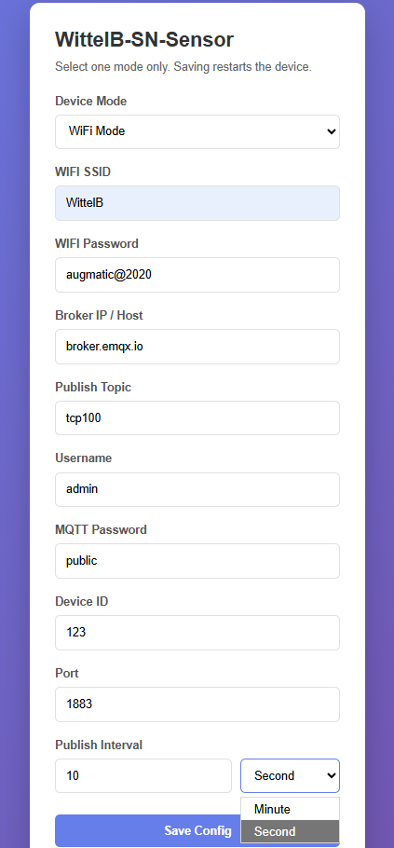
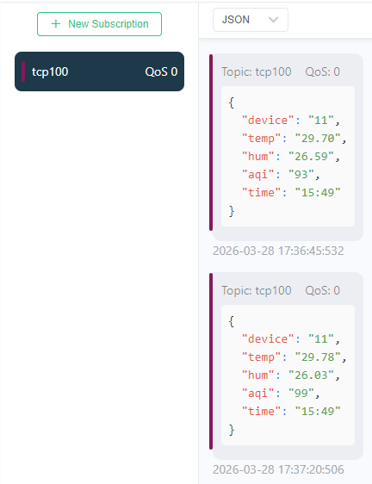

Image: 3 Image: 4
- Enter the local Wi-Fi credentials as shown in above image3 so the device can connect to that Wi-Fi network.
- Enter the MQTT credentials to transmit the sensor data to the cloud.
- Image 4 shows the sensor data at cloud for the selected topic.

NOTE: If the device is selected in WIFI Mode, the web interface will be accessible at any time, but it will not connect to Modbus RTU.

Contact Information
Augmatic Technologies Pvt. Ltd.,
Plot no 6, Shah Industrial Estate II,
Kotambi, Vadodara – 391510.
Email – Sales@wittelb.com
Support: support@wittelb.raiseaticket.com / +91 94038 92805

